Creativity and Calculation By GM Bong Villamayor

Powerchess Asia

Answer following exercises by using the given clue by the first move, this training if done regularly will enhance your creativity in generating tactics and deepen your calculating skill in the game.

1. Rxg7 1. Qa6+
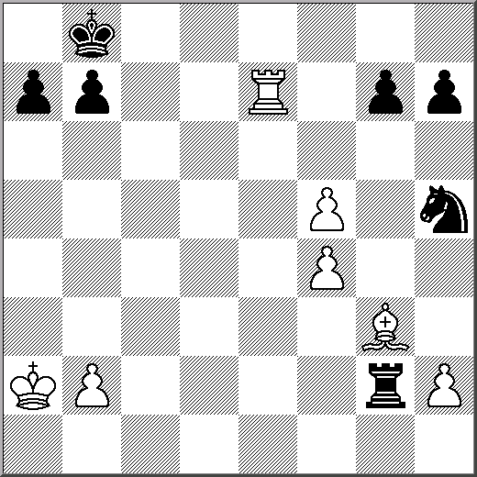
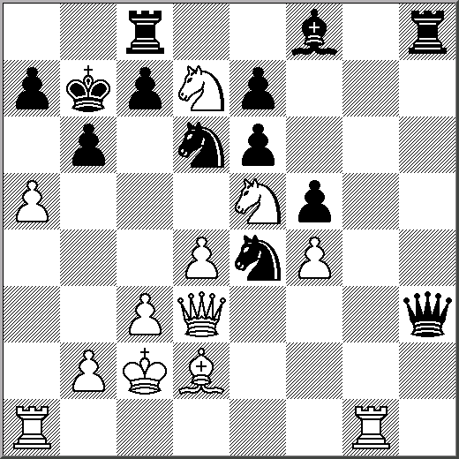

1. Nbc7+ Rxc7 2. ? 1. Ra8
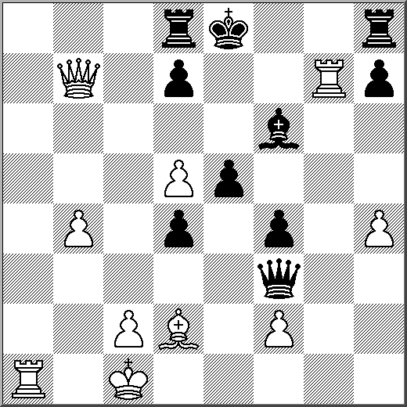
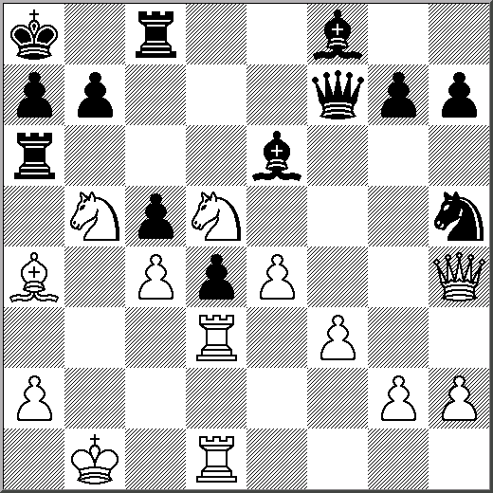

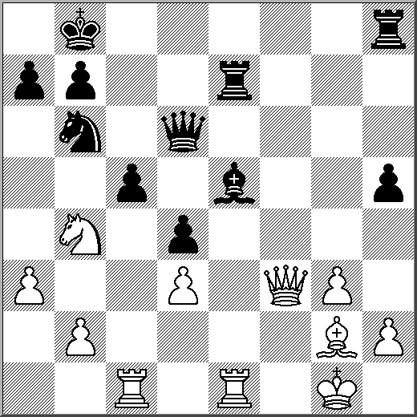
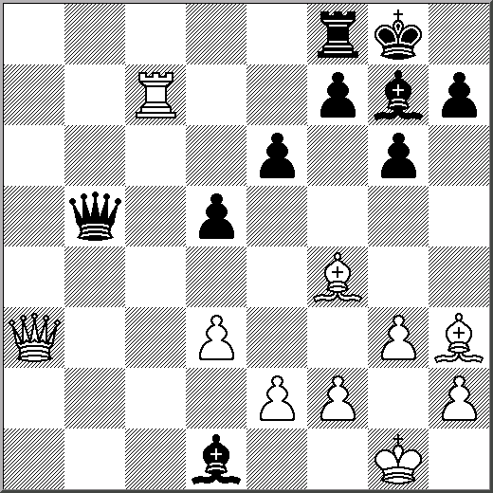
1. Rxc5 Qxc5 2. ? 1. Bxe6 fxe6 2. ?

